Data visualizations:

Shot clock vs 2 pt

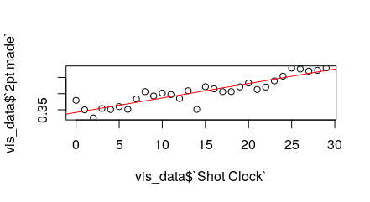

Residuals:

Min 1Q Median 3Q Max

-0.053156 -0.010157 0.002486 0.009977 0.037307

Coefficients:

Estimate Std. Error t value Pr(>|t|)

(Intercept) 0.3418752 0.0065488 52.20 < 2e-16 ***

vis_data$`Shot Clock` 0.0044737 0.0003878 11.54 3.75e-12 ***

---

Signif. codes: 0 ‘***’ 0.001 ‘**’ 0.01 ‘*’ 0.05 ‘.’ 0.1 ‘ ’ 1

Residual standard error: 0.01839 on 28 degrees of freedom

Multiple R-squared: 0.8262, Adjusted R-squared: 0.82

F-statistic: 133.1 on 1 and 28 DF, p-value: 3.755e-12

Shot clock vs 3 pt

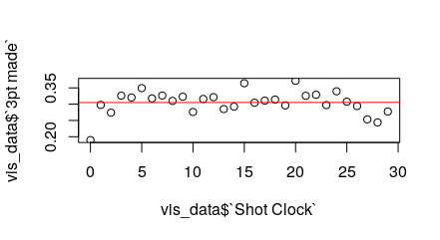

Residuals:

Min 1Q Median 3Q Max

-0.115268 -0.012339 0.005287 0.019833 0.066585

Coefficients:

Estimate Std. Error t value Pr(>|t|)

(Intercept) 3.049e-01 1.302e-02 23.415 <2e-16 ***

vis_data$`Shot Clock` 1.432e-05 7.712e-04 0.019 0.985

---

Signif. codes: 0 ‘***’ 0.001 ‘**’ 0.01 ‘*’ 0.05 ‘.’ 0.1 ‘ ’ 1

Residual standard error: 0.03656 on 28 degrees of freedom

Multiple R-squared: 1.232e-05, Adjusted R-squared: -0.0357

F-statistic: 0.0003448 on 1 and 28 DF, p-value: 0.9853

Shot clock vs percentage of 3 pt

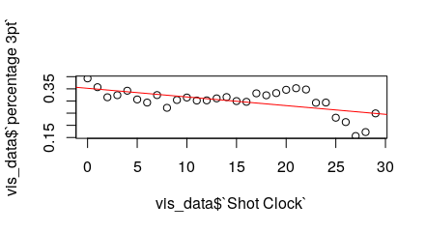

Residuals:

Min 1Q Median 3Q Max

-0.09989 -0.02536 0.00059 0.02583 0.07513

Coefficients:

Estimate Std. Error t value Pr(>|t|)

(Intercept) 0.3521047 0.0149915 23.487 < 2e-16 ***

vis_data$`Shot Clock` -0.0035604 0.0008878 -4.011 0.000409 ***

---

Signif. codes: 0 ‘***’ 0.001 ‘**’ 0.01 ‘*’ 0.05 ‘.’ 0.1 ‘ ’ 1

Residual standard error: 0.04209 on 28 degrees of freedom

Multiple R-squared: 0.3649, Adjusted R-squared: 0.3422

F-statistic: 16.08 on 1 and 28 DF, p-value: 0.0004085

Shot clock vs Points per shot

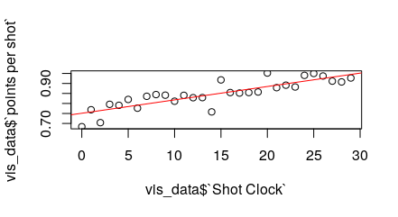

Residuals:

Min 1Q Median 3Q Max

-0.086935 -0.017552 -0.005214 0.027716 0.067195

Coefficients:

Estimate Std. Error t value Pr(>|t|)

(Intercept) 0.7512266 0.0128722 58.360 < 2e-16 ***

vis_data$`Shot Clock` 0.0066832 0.0007623 8.768 1.61e-09 ***

---

Signif. codes: 0 ‘***’ 0.001 ‘**’ 0.01 ‘*’ 0.05 ‘.’ 0.1 ‘ ’ 1

Residual standard error: 0.03614 on 28 degrees of freedom

Multiple R-squared: 0.733, Adjusted R-squared: 0.7235

F-statistic: 76.87 on 1 and 28 DF, p-value: 1.614e-09